Scratch Demo
Natick FOSS Meeting
July 6, 2011

Scratch is a visual programming language. It is easy to start using Scratch, even with kids or adults.

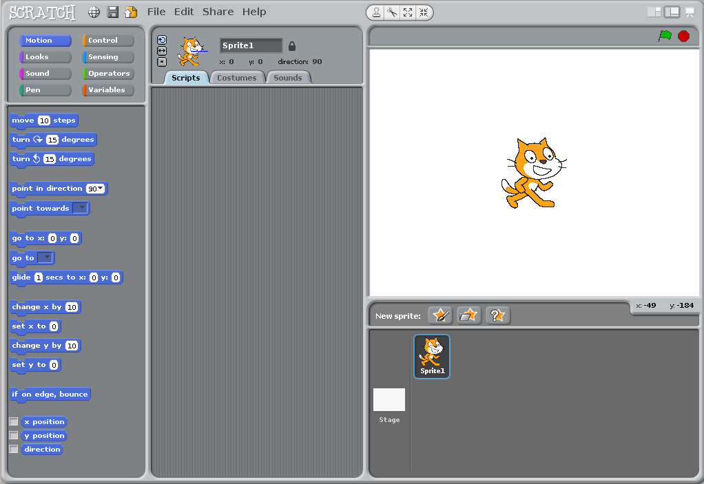

You can build a program by dragging “pieces” of code into place.

Changes are easy.

You can work quite a while before you need to use variables, but they are powerful in Scratch, just as they are one of the core ideas in any programming tool.

Scratch has its own integrated development environment (IDE).
It is a learning environment, not designed to create executable computer programs. All work happens in the IDE. Scratch takes almost no work to start, but can provide a very large space for learning.

Scratch has an online community which promotes sharing of the work you do.
Working with others to collaborate is encouraged.
Collaboration can be worldwide.

Resources:
Main Scratch site (MIT in Cambridge) http://scratch.mit.edu/
Support including tutorials: http://info.scratch.mit.edu/Support
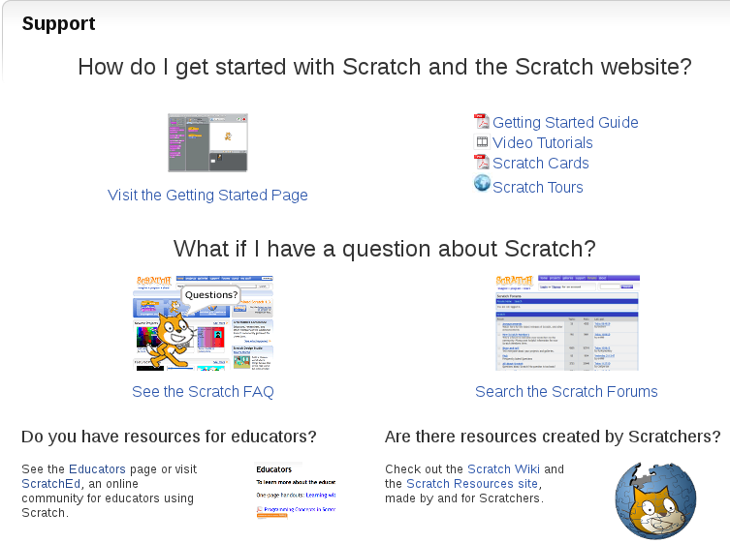

ScratchEd: http://scratched.media.mit.edu/

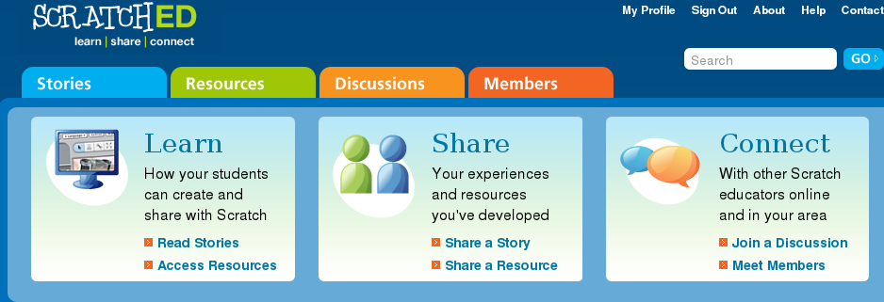

Can't Catch Me Video: http://scratched.media.mit.edu/stories/cant-catch-me (Story includes video.)
(Please duplicate: You may freely use this document which is licensed CC-Zero.)

